CSD 420 Advanced Java Programming
Module 3 Programming Assignment Generic Remove Duplicates
Zachary White
Darrell Payne
August 30, 2026

Overview
This assignment implements a generic static method, removeDuplicates(), that accepts an ArrayList of any reference type and returns a new ArrayList containing only the distinct values from the original list, in the order those values first appeared. The test program populates an ArrayList<Integer> with 50 random values between 1 and 20, runs it through removeDuplicates(), and prints both lists to the console for comparison.

How removeDuplicates() Works
The method signature is public static <E> ArrayList<E> removeDuplicates(ArrayList<E> list). The <E> declared before the return type introduces a type parameter scoped to the method itself, which is what allows the method to work with an ArrayList of any element type while the compiler still enforces type safety on both the input and the returned list.
Internally, the method walks the input list one element at a time with a for-each loop. A HashSet is kept on the side purely to track which values have already been encountered, since HashSet lookups run in constant time. A separate ArrayList collects the actual output. HashSet.add() returns true only the first time a given value is added and false on every subsequent attempt, so that single boolean check is enough to decide whether a value is new; if it is, the value is appended to the result list. Because the source list is scanned from front to back and elements are only ever appended, the output preserves the order in which each distinct value first appeared in the original list.

Compilation and Program Output
The screenshot below shows the program being compiled with javac and executed with java from the command prompt. The original 50-value list and the deduplicated list (18 distinct values in this run) are both printed to the console, confirming the method compiles cleanly and behaves as expected.
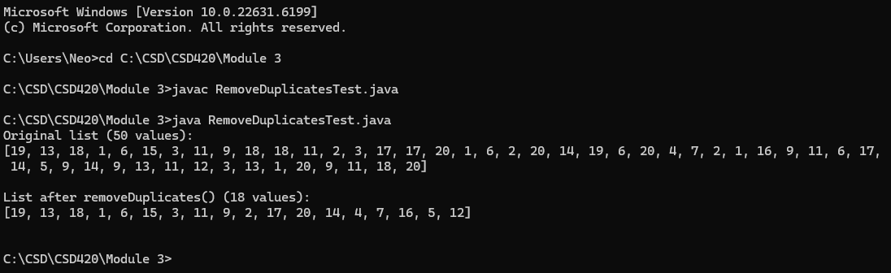
Figure 1. Command-line compilation and execution of RemoveDuplicatesTest.java

Conclusion
The program successfully demonstrates a generic method that removes duplicate values from an ArrayList while preserving the order in which values first occurred. Because the method is generic, the same removeDuplicates() implementation would work unchanged for an ArrayList of Strings, Doubles, or any other reference type without needing to be rewritten.

Sources

Liang, Y. D. (2023). Introduction to Java programming and data structures (13th ed.). Pearson.

Related Coursework Material via Module 3 ( Bellevue University )

